Accuracy versus Precision

Accuracy
The ability of the instrument to measure the accurate value is known as accuracy. In other words, the closeness of the measured value to a standard or true value. Accuracy is obtained by effective and correct methodology. Accuracy can be measured by calculating percent error.
Precision
The closeness of two or more measurements to each other is known as the precision of a substance. If you weigh a given substance five times and get 3.2 kg each time, then your measurement is very precise but not necessarily accurate. Precision is independent of accuracy. Precision is obtained by carful adherence to methodology and the use of precise instruments. Precision can be measured by calculating (absolute or percent) uncertainty.

Conclusion
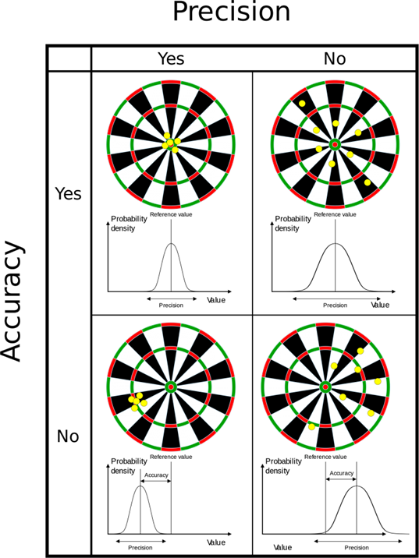
Accuracy is the degree of closeness between a measurement and the measurement’s true value. Precision is the degree to which repeated measurements under the same conditions are unchanged.

Accuracy and Precision Examples
A good analogy for understanding accuracy and precision is to imagine a football player shooting at the goal. If the player shoots into the goal, he is said to be accurate. A football player who keeps striking the same goalpost is precise but not accurate. Therefore, a football player can be accurate without being precise if he hits the ball all over the place but still scores. A precise player will hit the ball to the same spot repeatedly, irrespective of whether he scores or not. A precise and accurate football player will not only aim at a single spot but also score the goal.
If you take the measurement of the mass of a body of 20 kg and you get 17.4,17,17.3 and 17.1, your weighing scale is precise but not very accurate. If your scale gives you values of 19.8, 20.5, 21.0, and 19.6, it is more accurate than the first balance but not very precise.
The top left image shows the target hit at high precision and accuracy. The top right image shows the target hit at a high accuracy but low precision. The bottom left image shows the target hit at a high precision but low accuracy. The bottom right image shows the target hit at low accuracy and low precision.

Difference Between Accuracy and Precision
In the previous few sections having discussed what each term means, let us now look at their differences.
Accuracy | Precision
Accuracy refers to the level of agreement between the actual measurement and the absolute measurement. | Precision implies the level of variation that lies in the values of several measurements of the same factor.
Represents how closely the results agree with the standard value. | Represents how closely results agree with one another.
Single-factor or measurement. | Multiple measurements or factors are needed.
It is possible for a measurement to be accurate on occasion as a fluke. For a measurement to be consistently accurate, it should also be precise. | Results can be precise without being accurate. Alternatively, the results can be precise and accurate.

Practice Questions
Q1) The volume of a liquid is 26 mL. A student measures the volume and finds it to be 26.2 mL, 26.1 mL, 25.9 mL, and 26.3 mL in the first, second, third, and fourth trial, respectively. Which of the following statements is true for his measurements?
a. They are neither precise nor accurate.
b. They have poor accuracy.
c. They have good precision.
d. They have poor precision.
Answer: They have good precision.
Q2) The volume of a liquid is 20.5 mL. Which of the following sets of measurement represents the value with the best accuracy? Calculate the mean of this set of readings and the percent error for this value
a. 18.6 mL, 17.8 mL, 19.6 mL, 17.2 mL
b. 19.2 mL, 19.3 mL, 18.8 mL, 18.6 mL
c. 18.9 mL, 19.0 mL, 19.2 mL, 18.8 mL
d. 20.2 mL, 20.5 mL, 20.3 mL, 20.1 mL
Answer: The set 20.2 mL, 20.5 mL, 20.3 mL, 20.1 mL represents the value with good accuracy. The mean value is 20.3 (rounded from 20.275), and the precent error between 20.275 and 20.5 is 1.1%.

